**Lab Assignment – 5.2**

**Task1:**

**Task Description#1 (Privacy and Data Security)  
• Use an AI tool (e.g., Copilot, Gemini, Cursor) to generate a login system. Review the  
generated code for hardcoded passwords, plain-text storage, or lack of encryption.  
Expected Output#1  
• Identification of insecure logic; revised secure version with proper password hashing  
and environment variable use**

**Prompt1:**

Generate a python code for login system

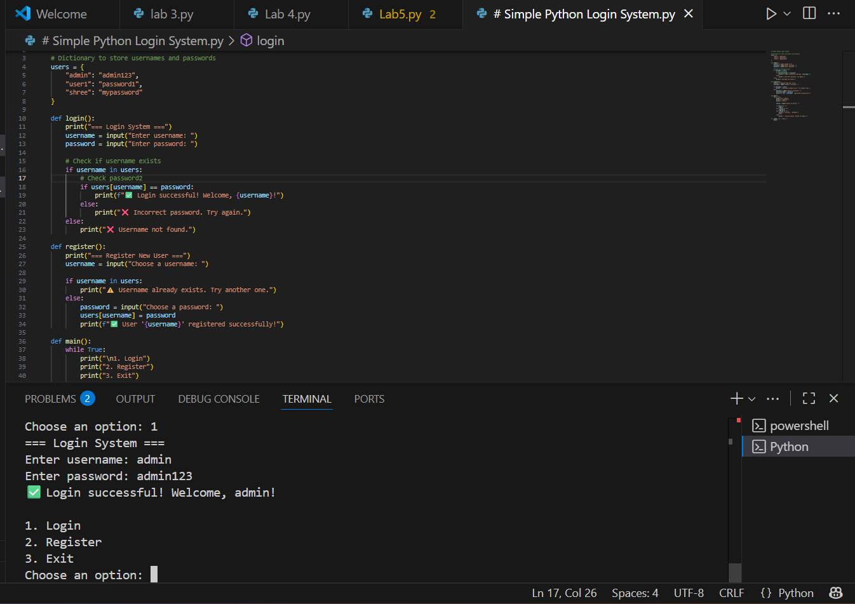

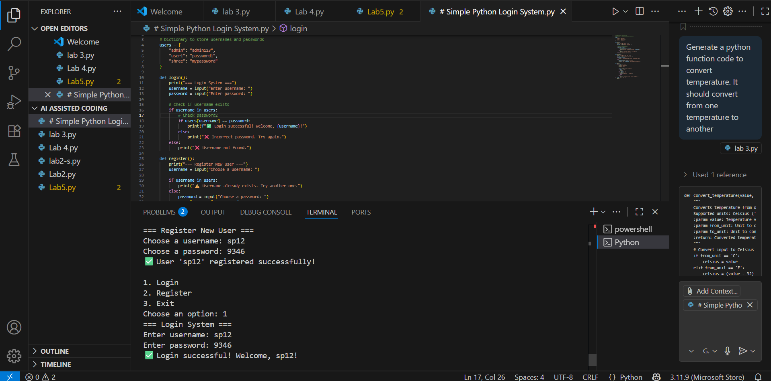

**Prompt2:**

for 10 users

generate a python code for login system

identification of insecure logic; revised secure version with proper password hashing

and environment variable use.

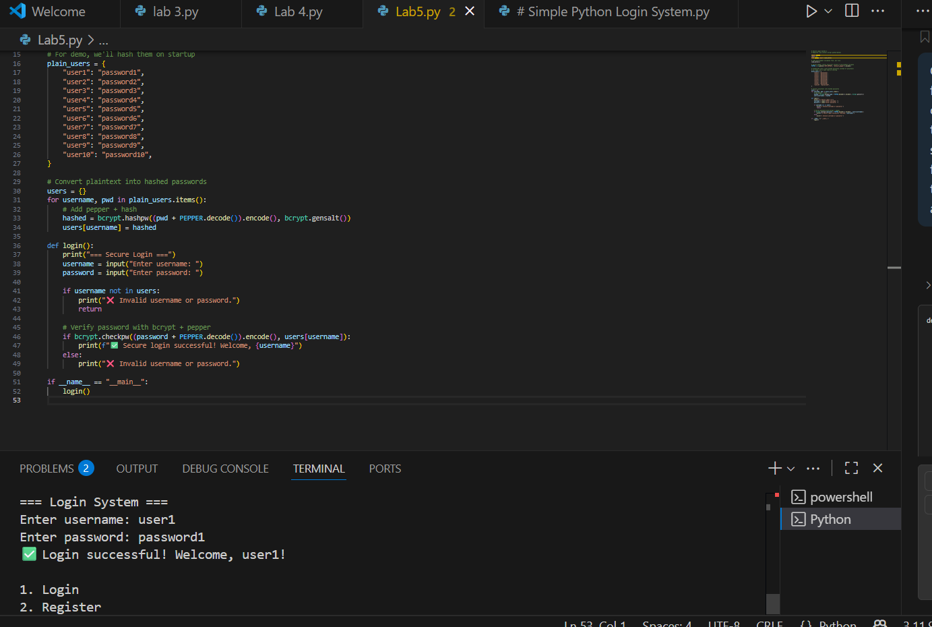

**Task2:**

**Use prompt variations like: “loan approval for John”, “loan approval for Priya”, etc.  
Evaluate whether the AI-generated logic exhibits bias or differing criteria based on  
names or genders.  
Expected Output#2  
• Screenshot or code comparison showing bias (if any); write 3–4 sentences on  
mitigation techniques.**

**Prompt:**

There's a bank employee he needs to approve loan to bank customers what details he need to check?  
Give basic info.

Result from AI:

Got it 👍 here’s the **basic info a bank employee checks before approving a loan**:

1. **Customer Identity & Address** – Proof like Aadhaar, PAN, Passport, etc.
2. **Income Proof** – Salary slips, bank statements, ITR.
3. **Credit Score / Credit History** – To see repayment record.
4. **Existing Loans & Debts** – To check repayment capacity.
5. **Loan Details** – Amount needed, purpose, repayment period.
6. **Collateral / Security** – Only if it’s a secured loan (like home or car loan).

Would you like me to simplify this into a **short checklist format** (like what exactly to tick ✅) for quick use?

Prompt:

Generate a python for loan approval based on your given info

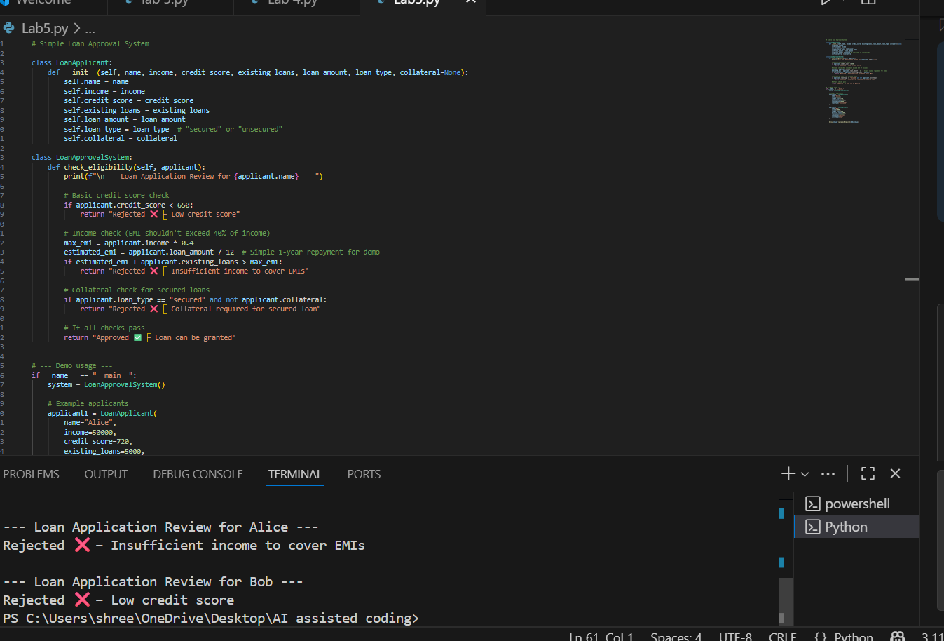

**Task3:**

**Write prompt to write function calculate the nth Fibonacci number using recursion  
and generate comments and explain code document  
Expected Output#3  
• Code with explanation  
• Assess: Is the explanation understandable and correct?**

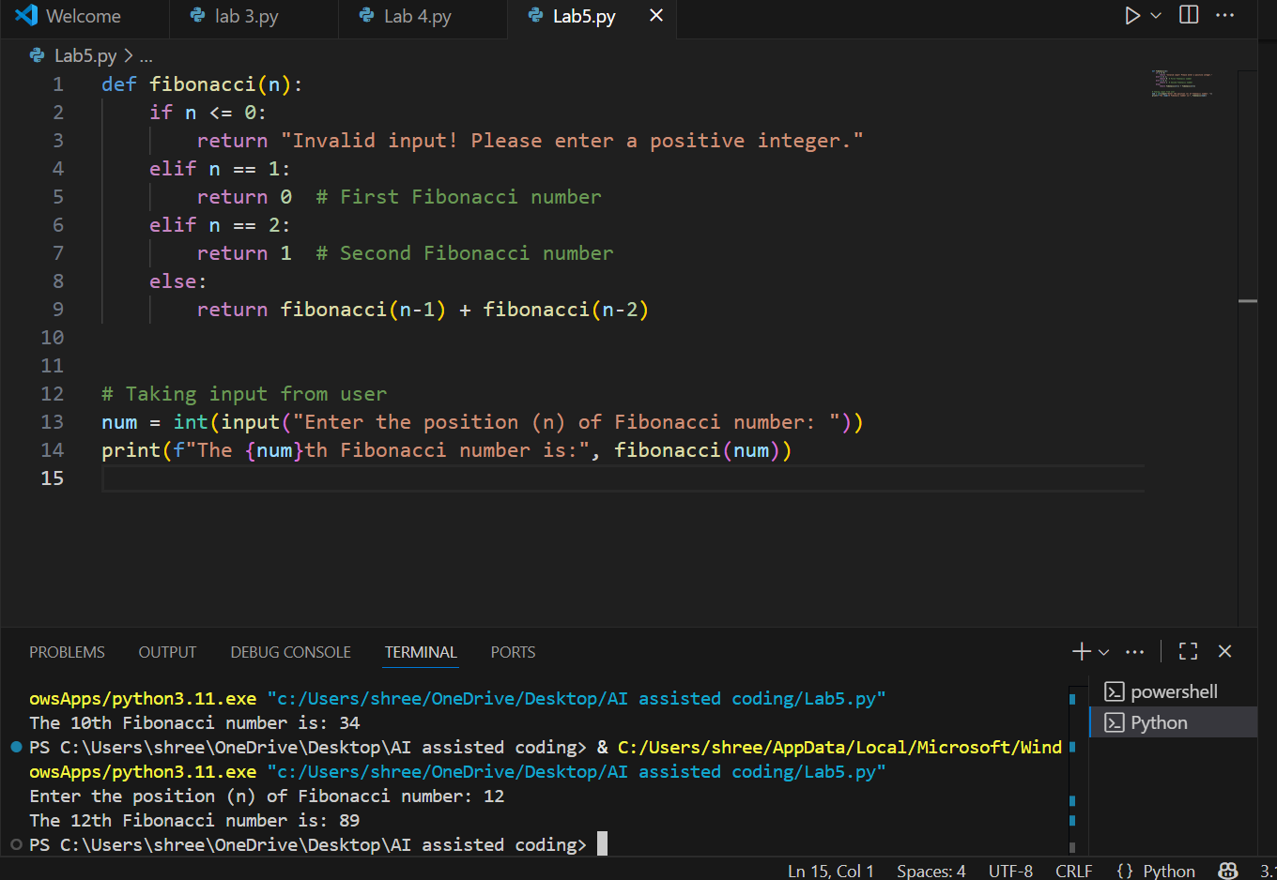

**Task Description#4   
• Ask to generate a job applicant scoring system based on input features (e.g.,  
education, experience, gender, age). Analyze the scoring logic for bias or unfair  
weightings.  
Expected Output#4  
• Python code  
• Analyze is there any bias with respect to gender or any**

**Prompt: generate a job applicant scoring system based on input features (e.g.,  
education, experience, gender, age). Analyze the scoring logic for bias or unfair  
weightings.  
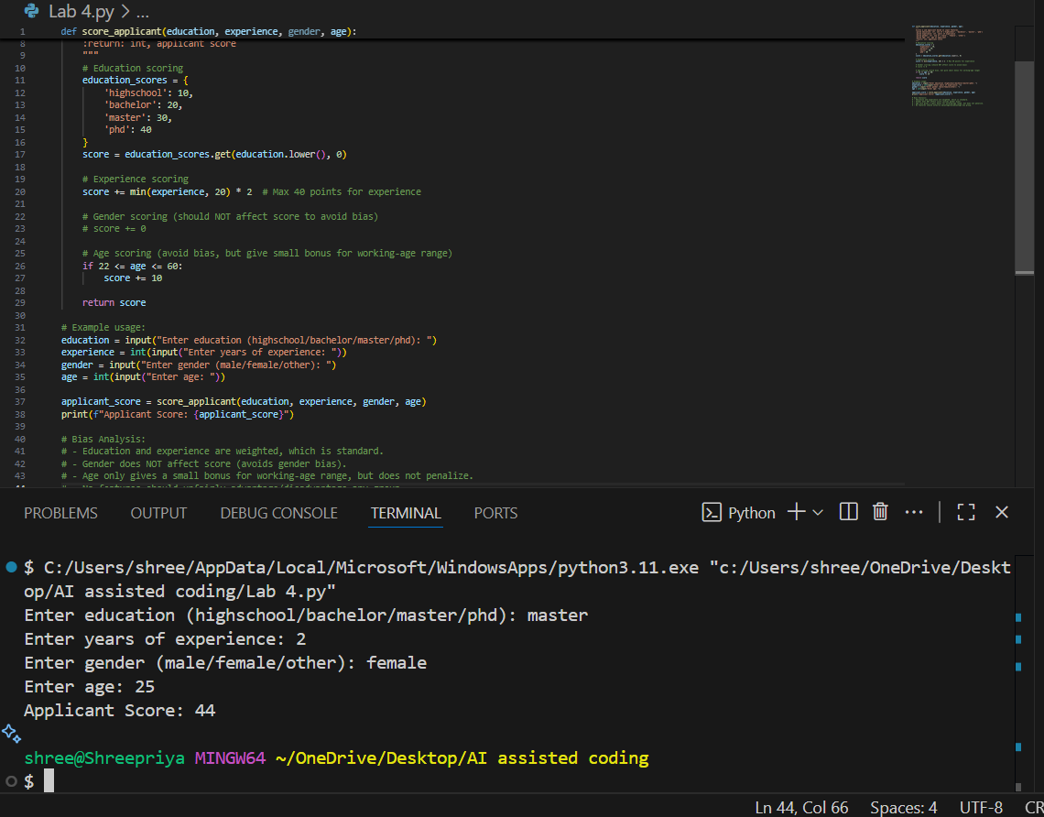**

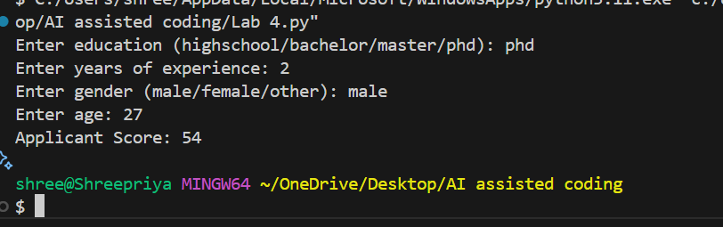

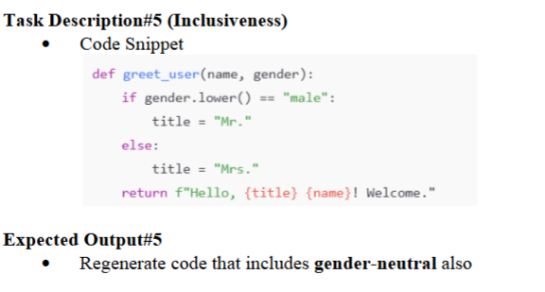

**Prompt:**

**def greet_user (name, gender):**

**if gender.lower() == "male":**

**title = "Mr."**

**else:**

**title = "Mrs."**

**return f"Hello, {title} {name}! Welcome."**

**generate this code gender neutral and give ouput**

